**SMART MIRROR USING INTERNET OF THINGS**

**INTRODUCTION**

This project is based on the design and development of the smart mirror that represents an interface for the home environment. This also consists of many features just as the usage of mobile phone in the form of mirror. A service-oriented architecture has been adopted to develop and deploy the various services, where the mirror interface, the appliances, and so on. With the wireless connectivity consisting of the embedded devices that are being used in various day-by-day activities, are changing and improving the standards of the quality of life.

**EXISTING SYSTEM**

This type of the smart mirrors are already existing in the market with the weather and news reports through the help of the mirror interface and the artificial intelligence and so on. Mostly this kind of smart products are used with the help of the raspberry pi. It is the best interface to be used in making such kind of products.

**PROPOSED SYSTEM**

This project is generally based on implementation of the smart mirror with adding more features which is not yet seen in the market further. It will have an authentication feature and with welcome message, and then open the interface of the mirror with a display showing the date time and respective notifications. There is a touch screen interface availability in it. And this will be connected through your mobile device with the help of Wi-Fi or Bluetooth, were you can even see the videos with the audios too.

**REQUIREMENTS**

* Raspberry Pi
* Android Phone
* Two-way Mirror
* Micro phone
* camera

**Software Requirements:**

* Android Studio
* Face detection with mood detection

**Languages:**

* Java for Making App
* Python or C for Raspberry pi

**BLOCK DIAGRAM**

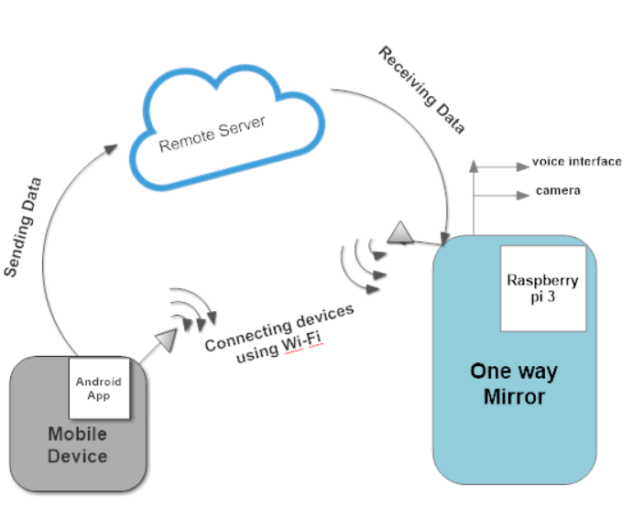

**CONCLUSION**

The main strengths of this project are that this is a new kind of smart device that people don’t see every day and it looks very spectacular. The platform has a very simple API that makes it very easy for developers to make apps. There was many difficulties we had faced during building this project regarding hardware connection, software, making UI reliable but at last it’s completed. Yes, it have some weakness and we will soon overcome from that. There are many future possibilities for this project and hopefully it will be continued.